Narrative for “Before You Print” Presentation. NVPS September 10, 2024 by Wayne Guenther
Photography as we practice the art today is overwhelmingly digital, and viewed on a display. I have no problem with that and don’t believe a print has any more authenticity than a digital view. However, there are opportunities to display and sell prints, and since you are here I assume you are interested in printing your work. Our club has three competitions this year (November, March, and May) where only one digital entry is allowed, but up to two prints. And the MAPV photo competition this year requires entries selected by the judges on October 4th to be printed/matted before the November 1 conference opening. Further, many juried art competitions like the Art League of Alexandria monthly shows require selected digital submissions to be printed and framed.
The axiom I want to plant tonight is that the mat window dimensions are key to your editing decisions before you print. The corollary is the expectation that several predetermined mat dimensions will save money compared to printing without regard to aspect ratio and size. Finally, the matted print must look good while meeting both generally accepted standards and competition specifications. My ideas of what works are advisory, and by no means the only way to achieve an acceptable matted and/or framed print. The process here uses Photoshop tools exclusively to keep it simple and assumes members have that program. The Adobe photography apps subscription includes both Lightroom and Photoshop for $10 a month.
Camera menu setting that have bearing on editing, with subsequent bearing on printing.
- RAW files provide the most flexibility in editing, but .jpg file also work. In using .jpgs set the compression to zero by selecting L-F (large-file) setting.
- The dpi setting should be 300, and the color space set to Adobe RGB 1994.
- Check that the native file capture ratio is the default: 3:2 for full frame and AP-C sensors; 4:3 for micro-four-thirds.
- Android and iPhone cameras have 4:3 native ratios which can be changed to 1:1 and 16:9 before exposure, and cropped after exposure.

Current digital cameras create far larger file sizes than needed to make a mid-sized print. Olympus Systems 20 meg sensor is the smallest of ILC cameras, and its native uncropped 13 x 17 inch file will fit a 19 x 23 external size mat with 3 in borders all around. Editing to a window size I advocate requires discarding pixels during file resize, yet we retain enough to make a print. Some current smart phone files may need to be “upressed”, a topic for another day.

One of the first digital editing tasks is to decide on the crop, and in that process decide if the original ratio works OK. If the original ratio is maintained, then the standard mat sizes I recommend will work. If you have a 3:2 ratio file (for example) and decide it should be cropped in 16:10 ratio, it will require a custom mat for the print. This is not necessarily a problem if the image is outstanding at that crop ratio. Buy a custom mat, and if the piece doesn’t sell replace the print with the next 16:10 ratio print you make.

This chart depicts the mat window dimensions, border size and external size which will accept scaled-down file sizes to fit the windows. The 17 x 13 and 17 x 14 external sizes are particularly useful. After selecting the pre-set mat, the decision in re-sizing is whether to place the print edge under the mat (expand the print size) or create a border between the image and the window (contract the print size).
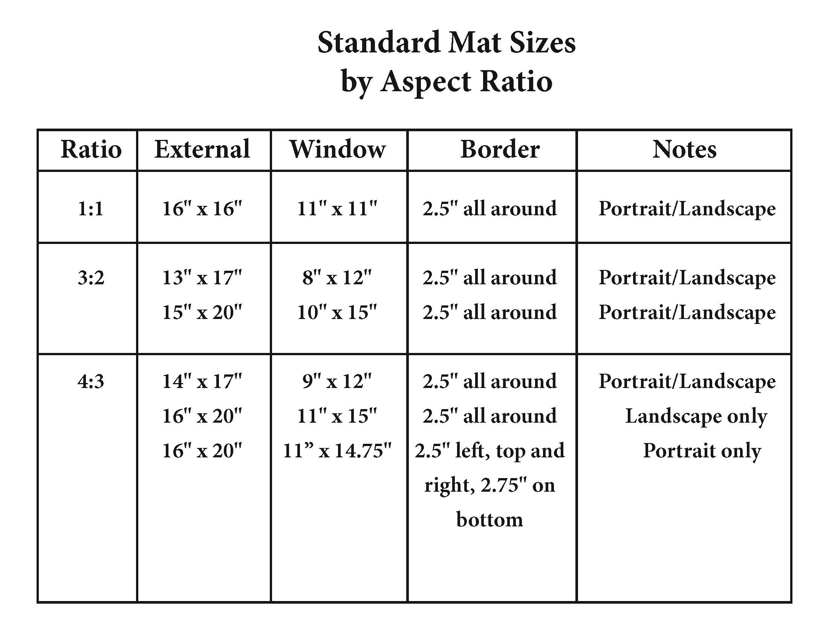
To prepare a file for commercial or home printing, finishing editing and open the file in Photoshop.
- Commercial printers require a file bit depth of 8/bits, while that setting doesn’t matter to home printers. To check, in Photoshop go to Image/Mode and view the bit-depth setting. Change to 8-bit if necessary and exit.
- Next resize the file by Image/Size, and the size dialog box opens. Check that the width and height fields drop down options has “inches”, the resolution shows 300 dpi, the resample Automatic box is checked, and the W-H boxes are ratio connected.
- Here is a resizing example using the 17x13 inch mat with a 12 x 8 window where we want the image to fit under the mat window with no border.
- Image/Size opens the Photoshop size dialog. Change the Width to the window size of 12 inches, and the height will automatically rescale to 8 inches. This is a test that the 3:2 file ratio does indeed scale to the selected new dimensions and sets up the next entry.
- Without hitting OK, change the long dimension (12 in this example) to 12.2, and the short dimension will automatically change to 8.133. This is sufficient expansion so that the commercial print image will always fit under the mat window after the lab adds its .125 oversize amount (discussed below). Click OK.
- If printing at home, to expand for under the window mounting change the long dimension to 12.2, unlock the aspect ratio function and enter 2.2 for the short dimension. Click OK and you are ready to print.
- The image for the commercial lab shows resized as above. With the Zoom tool (magnifying glass) active, click anywhere on the image and select “print size” to get the correct size representation on the display.
5. Now you have to overlay the 12.2 x 8.133 inch file on a new document in Photoshop for the commercial printer. Otherwise, the lab will take the file and either crop it or expand it to fit their paper, and the size you need for the mat window will be lost. Go to the commercial site and find what print/paper sizes they offer and select the one that your image will fit in with decent room. Nations Photo Lab for example has a 14 x 10 inch size which gives about a 1.8 inch border all around the example image. (Printing at home also requires selecting paper size larger than the image size.)
a. With your edited and resized file open in Photoshop, click File/New and when the selection box opens enter: width as 14 inch; height as 10 inch; resolution as 300; color mode RGB; bit depth 8; background content, White; Color Profile, Adobe RGB; and Pixel Aspect leave as default Square Pixels. Click “Create” and the new solid white document opens on the desktop, partially hiding the original image.
b. Select the original image by clicking on it. It comes to the forefront and shows in the Layer box as “background”. Click and hold on that layer box indicator and hold down the Shift key, then drag the original file on top of the New white document and release the mouse. The original image will automatically center on the new document and stay active in front of the original file. Since this is the file going to the commercial lab, use File/Save-As to place the document in a new location changing the File Name AND change the file type to .jpg. When you click OK the jpg quality option appears; enter 12 for the highest quality and close. The original resized file remains active in the Photoshop window. To avoid overwriting the base file it came from you can either Save As with a new file name, or close without saving (erasing all the editing actions). **

I sampled the services of two commercial printers, Mpix https://www.mpix.com/ and Nations Photo Lab https://nationsphotolab.com. Both offer several paper grades/surfaces and at least two qualities of prints. Both were quick in order processing, and two-four days receipt to ship. Mpix is in Kansas and Nations is north of Baltimore so there is a difference in shipping time and cost. I have sample prints from them on the table. All are acceptable representations of my images. The most important thing I learned is that they have built in “oversizing” of the submitted file dimensions by about 2% to compensate for drift in the paper through their roller mechanisims. Although that insures the customer’s image will fill the paper size, it means our expected exact sizing will not occur. All but one of my sample prints was .125 inch too long in both dimensions. From a practical perspective I would elect to have my image under the window edges (no border) and size my commercial file .2 inch over on the long dimension and let Photoshop scale the short dimension. This expansion added to their approximate oversize will give you around .3 inches to place under the window of the mat. See below for their expanded logic for “over printing”.

I highly recommend ordering pre-cut mats and backing from an art supply/framing service. I have used Framemasters in Merrifield VA for 30 years and I get nothing from my plug. They (and other local mat/framing suppliers) deserve community support in the same logic as local camera shops do. Regarding mats for photographs going to competitions and display:
- White is the designated color, not off-white or cream. Virtually all mats on the marketplace are four-ply or higher, a requirement for NVPS and MAPV. Four-ply is least expensive and works fine. Framemasters least expensive white mat board is Peterboro AS4471 Digital White.
- The core must be white, so that when cut the white shows at a 45 degree angle.
- The mat/print must be secured to a stiff backing, recommended as acid-free foam core of at least 1/8th inch (3/16th inch is a little stiffer at either no or negligible cost increase). Do not use mat board as a backing; it is not sufficiently ridged and may be cause for competition rejection.
- The borders forming the window should be equal distance all around, (e.g. 2.5x2.5x2.5x2.5) or “weighted” on the bottom (e.g. 2.5 left x 2.5 top x 2.5 right x 3 bottom). Although MAPV mat guidance specifically indicates the borders need not be the same dimension without addressing “bottom weighting”, and the current NVPS mat guidance doesn’t address border dimensions, professional practice follows the mat guidance border dimensions I suggest.
- According to their relative websites, NVPS prohibits markings on the front of the mat, but MAPV allows the makers name. Both require information needed on the back of the entry.

A word on photo printers.
- Printers designed to optimize photo printing are required to produce professional work. For Epson, their optimized printers have “SureColor” in their title. For Canon look for “PIXMA-Pro” or “PROGRAF-Pro” in the title. Price is sensitive to ink type (dye-based cheaper and pigment-based more expensive), number of ink cartridges, and carriage width (commonly 13 in or 17 in), and tech specs like number of nozzles, resolution, print speed, integrated matt black ink, etc. Like digital cameras, ink jet printers and inks have dramatically improved over the last 15 years to where even entry level units produce outstanding prints, and the iterations of new models offer few clearly needed features. I bought my Epson SureColor P800 in 2020, and I won’t upgrade it unless it breaks.
- A printer is an investment and constant expense in paper and ink. My standard Canson 13x19 paper costs just under $4.00 a sheet, and the P800 ink cartridges cost $61 X 8 for $488/set. I’ve never calculated a “cost per print”, but I know I spent $515 in paper and ink last year, and this year to date it’s $323. Even so, my volume of printing would have cost far more from a commercial service so it’s economical for me, not to mention convenient. Ask me later if you have individual questions about home printing.

Things You Will Need to mat a print at home. Their utility will be evident in the matting demonstration.
Exacto-knife with #11 blades; steel edge ruler of at least 18 inches; removeable double-sided tape; large cutting board; metal yardstick; cotton gloves; 1 inch framers tape; hair dryer; and bone folder tool. A quality circular blade paper cutter also comes in handy. Protective bags at https://www.clearbags.com/ shop in the “Crystal Clear” section with flap seal

Exact Sizing a Print by Commercial Service (From Nations Photo Lab Tech Support)
Digital printers have what is called over sizing. Over sizing is a process in which the image being developed onto the photo paper is magnified by a certain percentage to counteract paper shift within the printer. Photographic paper is loaded into the printers in rolls. As the paper travels from the roll through the machine it can drift up to 1/8 of an inch by the time it reaches the lasers (or ink jet head) that expose the paper with the image. No amount of calibration on the paper path can prevent this drift. A 1/8 of an inch is about half the radius of the pen or pencil on your desk. The over sizing that is applied to each image runs between 1.5% -1.7%; we generally quote the percentage at 2% for a round number to work with. How can you use this information? Well the over sizing is so minimal, that 99% of your orders will not be effected by it. However, in certain instances where you may have images butted up against the outer edge like in a collage, text, or a pin stripe around an image's perimeter, you will want to take this 2% value into consideration. In most cases you can do very simple math to calculate the expected over sizing. Our message is to add the 2% additional space to the perimeter of any potentially affected image. For regular prints, such as an 8x10, the additional leeway you need to provide is 1/16 of an inch in the 8-inch dimension and 1/5 of an inch in the 10-inch dimension. Of course, the larger the print dimensions, the more image space effected by over sizing, thus the more padding that is needed. The zoom for exact sizing can vary a bit, and it can shift from side to side, or top to bottom, but we do our best to all the printing as evenly as possible.

