Fill versus Opacity
A member asked me the other day about the difference between the Fill and the Opacity slider adjustments in the Layer Palette. I'm happy to say, that thanks to Google I have a reasonable answer to the question, but it probably won't affect many of us.
This is an image with second layer and Drop Shadow effect added to provide the darker area to the right and below the top layer. The top layer has a Gaussian Blur of about 6 pixels applied to everything except the goal keeper, which helps to make the goalie jump out of the image, but the effect is a little too obvious. A subtler approach would be to soften the blurred layer, which can be applied by simply adjusting the Opacity of the blurred layer.
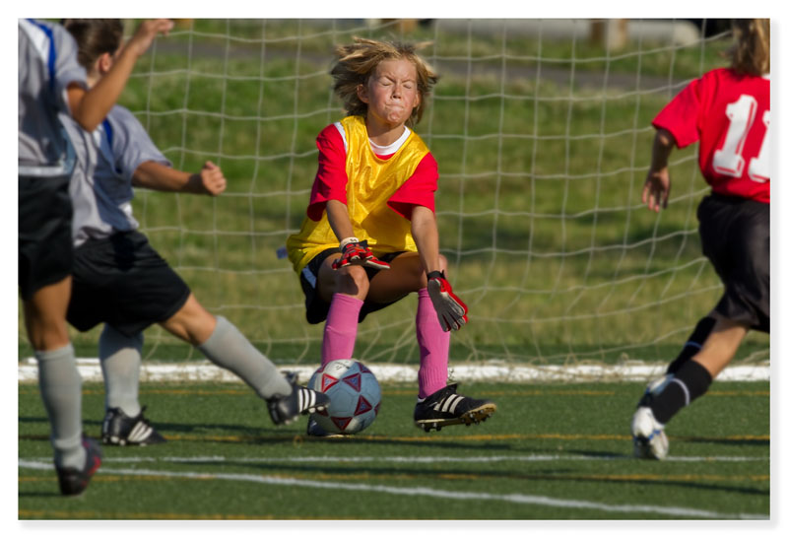Illustration 1: Image with Drop Shadow and too much Gaussian Blur
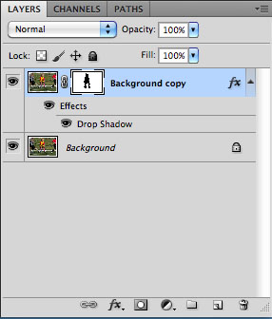Illustration 2: Layer Palette
When you adjust the Opacity slider of a layer, it affects the opacity of all aspects of the layer. If you have applied any layer effects, like a Drop Shadow, they will be affected by the Opacity slider just like the content of the layer itself. Note in the image below that the Drop Shadow has essentially disappeared.
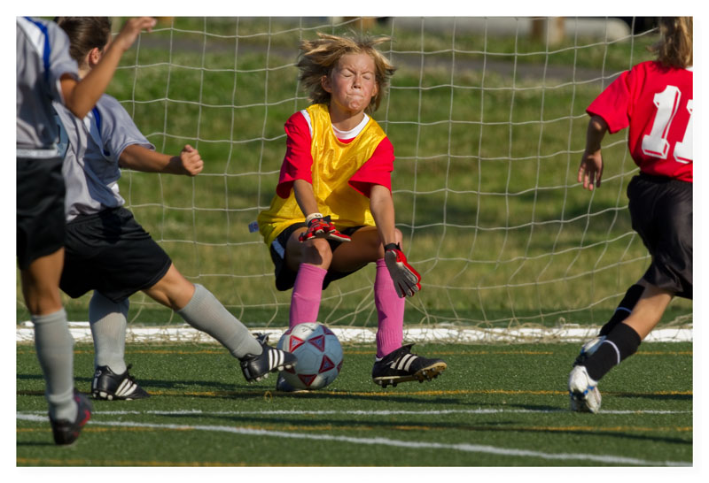Illustration 3: Image with Opacity adjusted to 20%
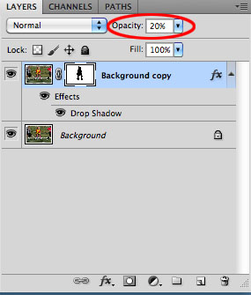Illustration 4: Layer Palette - 20% Opacity
However the Fill slider will only affect the content of the layer and not the layer effects. This allows you to adjust the opacity of the layer content independent of the opacity of the layer effect.
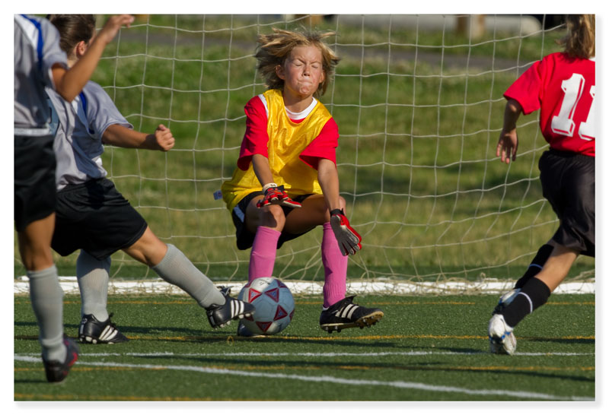Illustration 5: Image with Fill adjusted to 20%
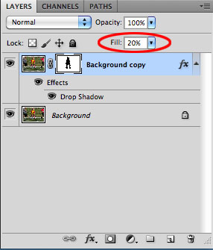Illustration 6: Layer Palette - 20% Fill
As photographers, layer effects are not a necessary component of our tool box, but as graphic artists they may be. For instance, this drop shadow to gives the image a feeling of increased depth. These types of effects are simple to make by applying effects to layer, and if you need to adjust the opacity of that layer, understanding the difference between the Fill and Opacity sliders will put you ahead of the game.

Matthew Schmidt

